**Context**

|  |  |
| --- | --- |
| Image result for s&p 500 data set bull  **Capstone Analytic Report and Research Proposal** | C:\Users\Anu Liyanagamage\AppData\Local\Microsoft\Windows\INetCache\Content.MSO\13137FEC.tmp  Dataset:  S&P 500 stock data Historical stock data for all current S&P 500 companies. Analysis of the Apple Stock.  Anu Liyanagamage |

The Standard & Poor's 500 (S&P 500) Index represents the risk and return performance of the biggest companies in the US. The index indicates of how these large companies are performing on a day-to-day basis. Some of the top companies under the umbrella of S&P 500 is Apple, Facebook, Amazon, GE, etc. By studying and evaluating past data investors and traders attempts to gain an edge in the markets by making informed buying and selling decisions.

**Data Set**

Fanatical datasets are an interesting as they provide valuable financial information. Finding a clean date set from web was a challenge even though there are many sites such yahoo finance and marketwatch. The dataset that was chosen for this analysis is from Keggle.com containing 5 years of S&P 500 stock data in csv file format. Following data set provides S&P 500 data from the years 2013-2018.

**The columns included in the pandas data frame are**

Open (price of the stock at market open)

High (Highest price reached in the day)

Low Close (Lowest price reached in the day)

Volume (Number of shares traded)

Name (the stock's ticker name)

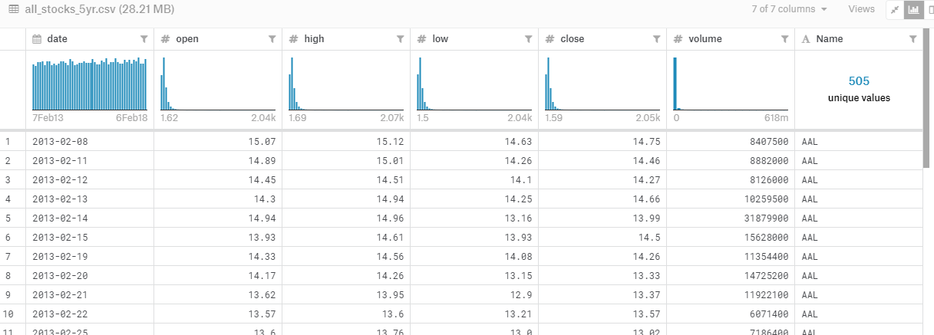

**Linking file to Jupiter Lab**

Once the File is downloaded the file can be linked to Jupyter lab by the following command.



**Analysis of the Apple Stock**

Apple is a Technology Company that sells consumer electronics, computer software, and online services.  In this project the Apple stock will be analyzed with its performance by calculating the percent change, finding correlations to its bestselling product (the iPhone) and how apple stacks against its competition.

**Finding the Apple stock from the dataset.**

Apple stock (AAPL) was assign to the (df1) data frame which finds column “Name” that will be equal to the apples stock symbol “AAPL”

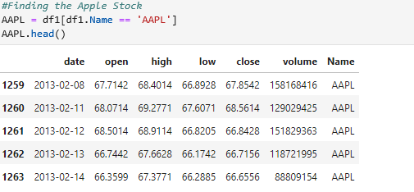

**Average volume and the total return**

Statistics function is used to calculate the average volume.

The total return of Apple from this data set is 1.43%

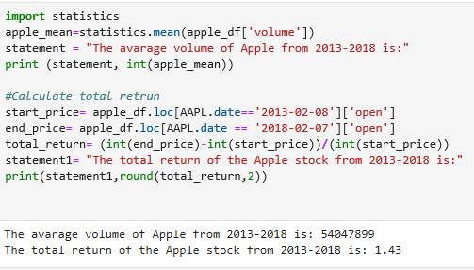

**Calculating Percent change of Apple Stock**

Percent change represents the degree of change over time. This dataset has not provided the percent change. Calculating percent change can be done by subtracting the close price from the opening price and divide the difference by the close price. Then, multiply by 100.

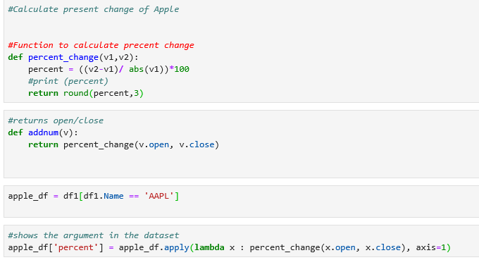

**Data set after Percent Change**

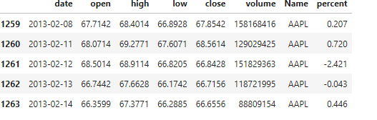

**Plotting Percent Change**

Date frames has been assigned to equal the dates and cumulative sum of the percent change over the period of time. The same formula will be used to calculate the percent change for Apple’s competitors.

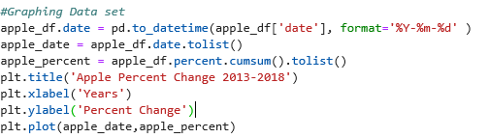

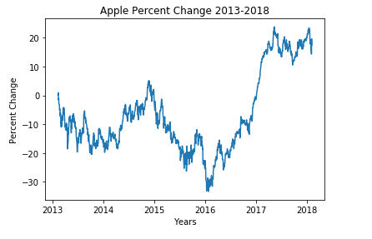

**Amazon Percent Change**

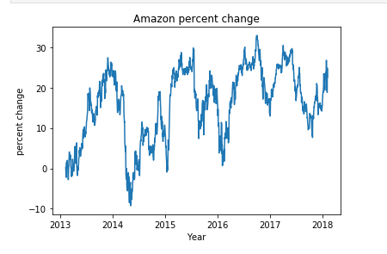

**Google Percent Change**

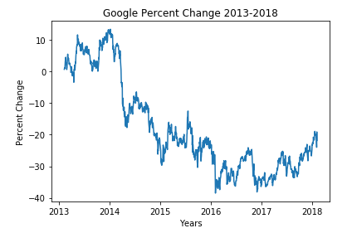

**Microsoft Percent Change**

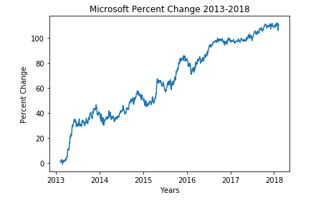

**Comparing the competition to Apple?**

How does Apple stack up to its competitors in the tech field? This chart shows the percent change for each company. Microsoft seems to be leading the pack in terms of percent change with steady growth and very little price changes over time.

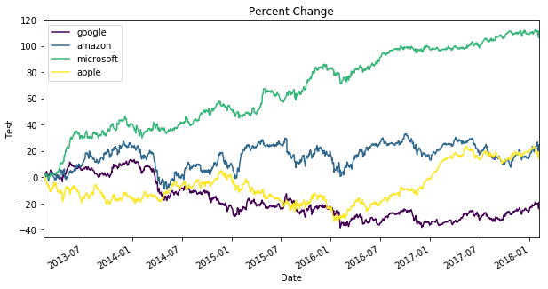

**How did the IPhone release effect the stock price?**

Nothing is more exciting for Apple enthusiast as the new IPhones that gets released every September. To find the correlation between iPhone release and its stock price the exact date is matched with the opening price of the stock.

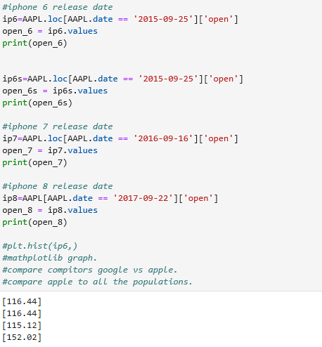

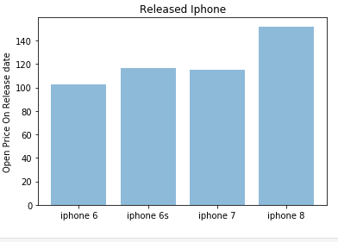

This graphs shows the increase in the opening price of the apple stock over the 4 year time period. The stock seems to increase every year along with the newly released iPhone.

**Final Analysis.**

This data set provided valuable insight on the S&P500’s top tech companies. Percent change is one of the missing pieces in this data set. The process finding the percent change was challenging were it required step by step functions that linked to the dataset. Plotting each company provided clear visual analysis of its performance. Creating data frames to gather data from the dataset to plot was a challenge. But further questions arose by these visualizations. For example why did google have a major drop in 2014, maybe indicating the stock split? .Amazon rises end of every year? Perhaps more sales during the holiday seasons. Microsoft had a big jump in 2013, release of Xbox One can be the answer. Going forward Time series analysis can be used to identify trends seasonal variations of markets to generate predictions for the future.